Here are some questions about Jola's birthday party.
How would you represent them using:
- words?
- pictures?
- numbers?
- objects?
- other ways?
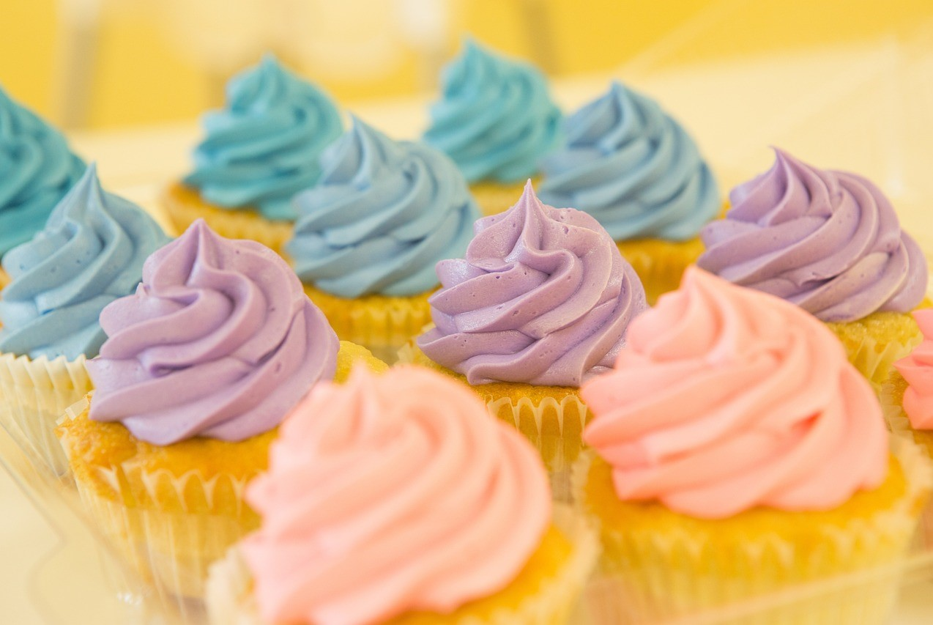 | Jola has 24 cupcakes to share equally between 3 plates for her birthday party.  How many cakes will go on each plate?
There are 8 children coming to the party (including Jola). They are all going to the cinema.  How many cars will they need to take them there? Each car can take 4 children and a driver. | 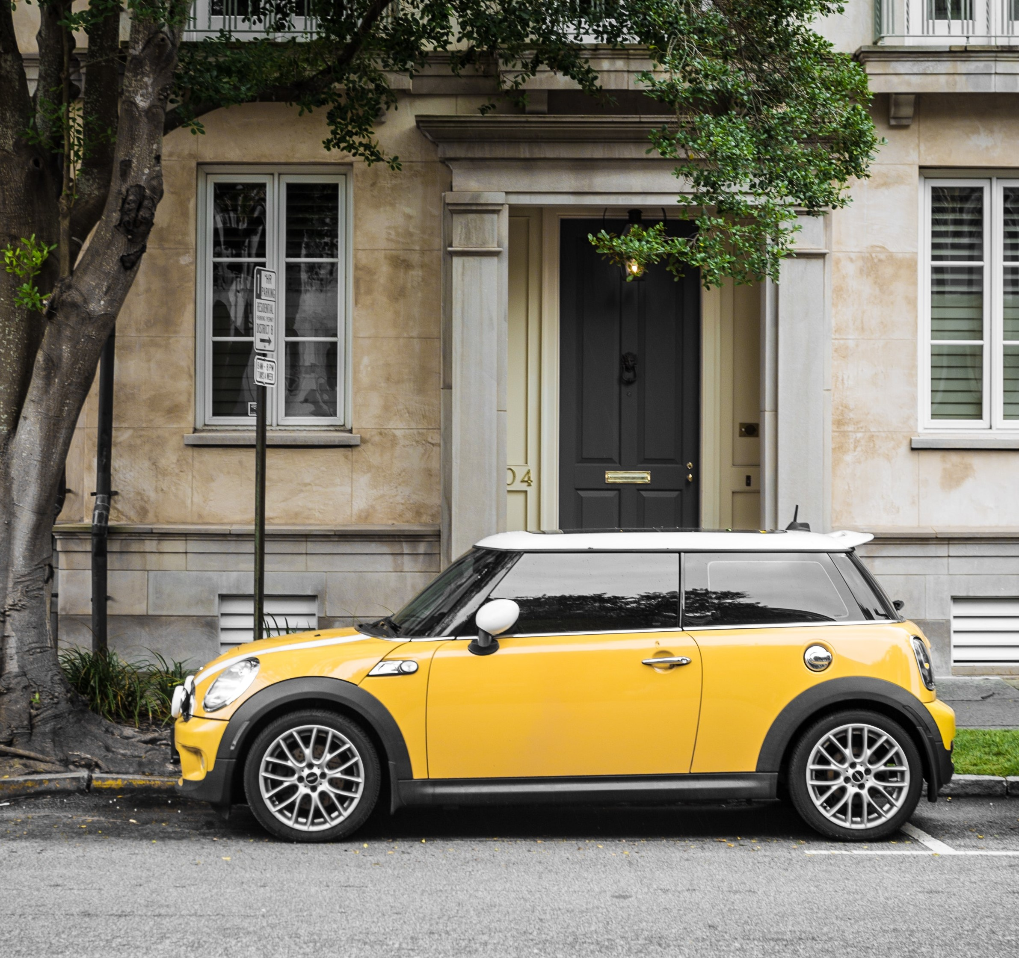
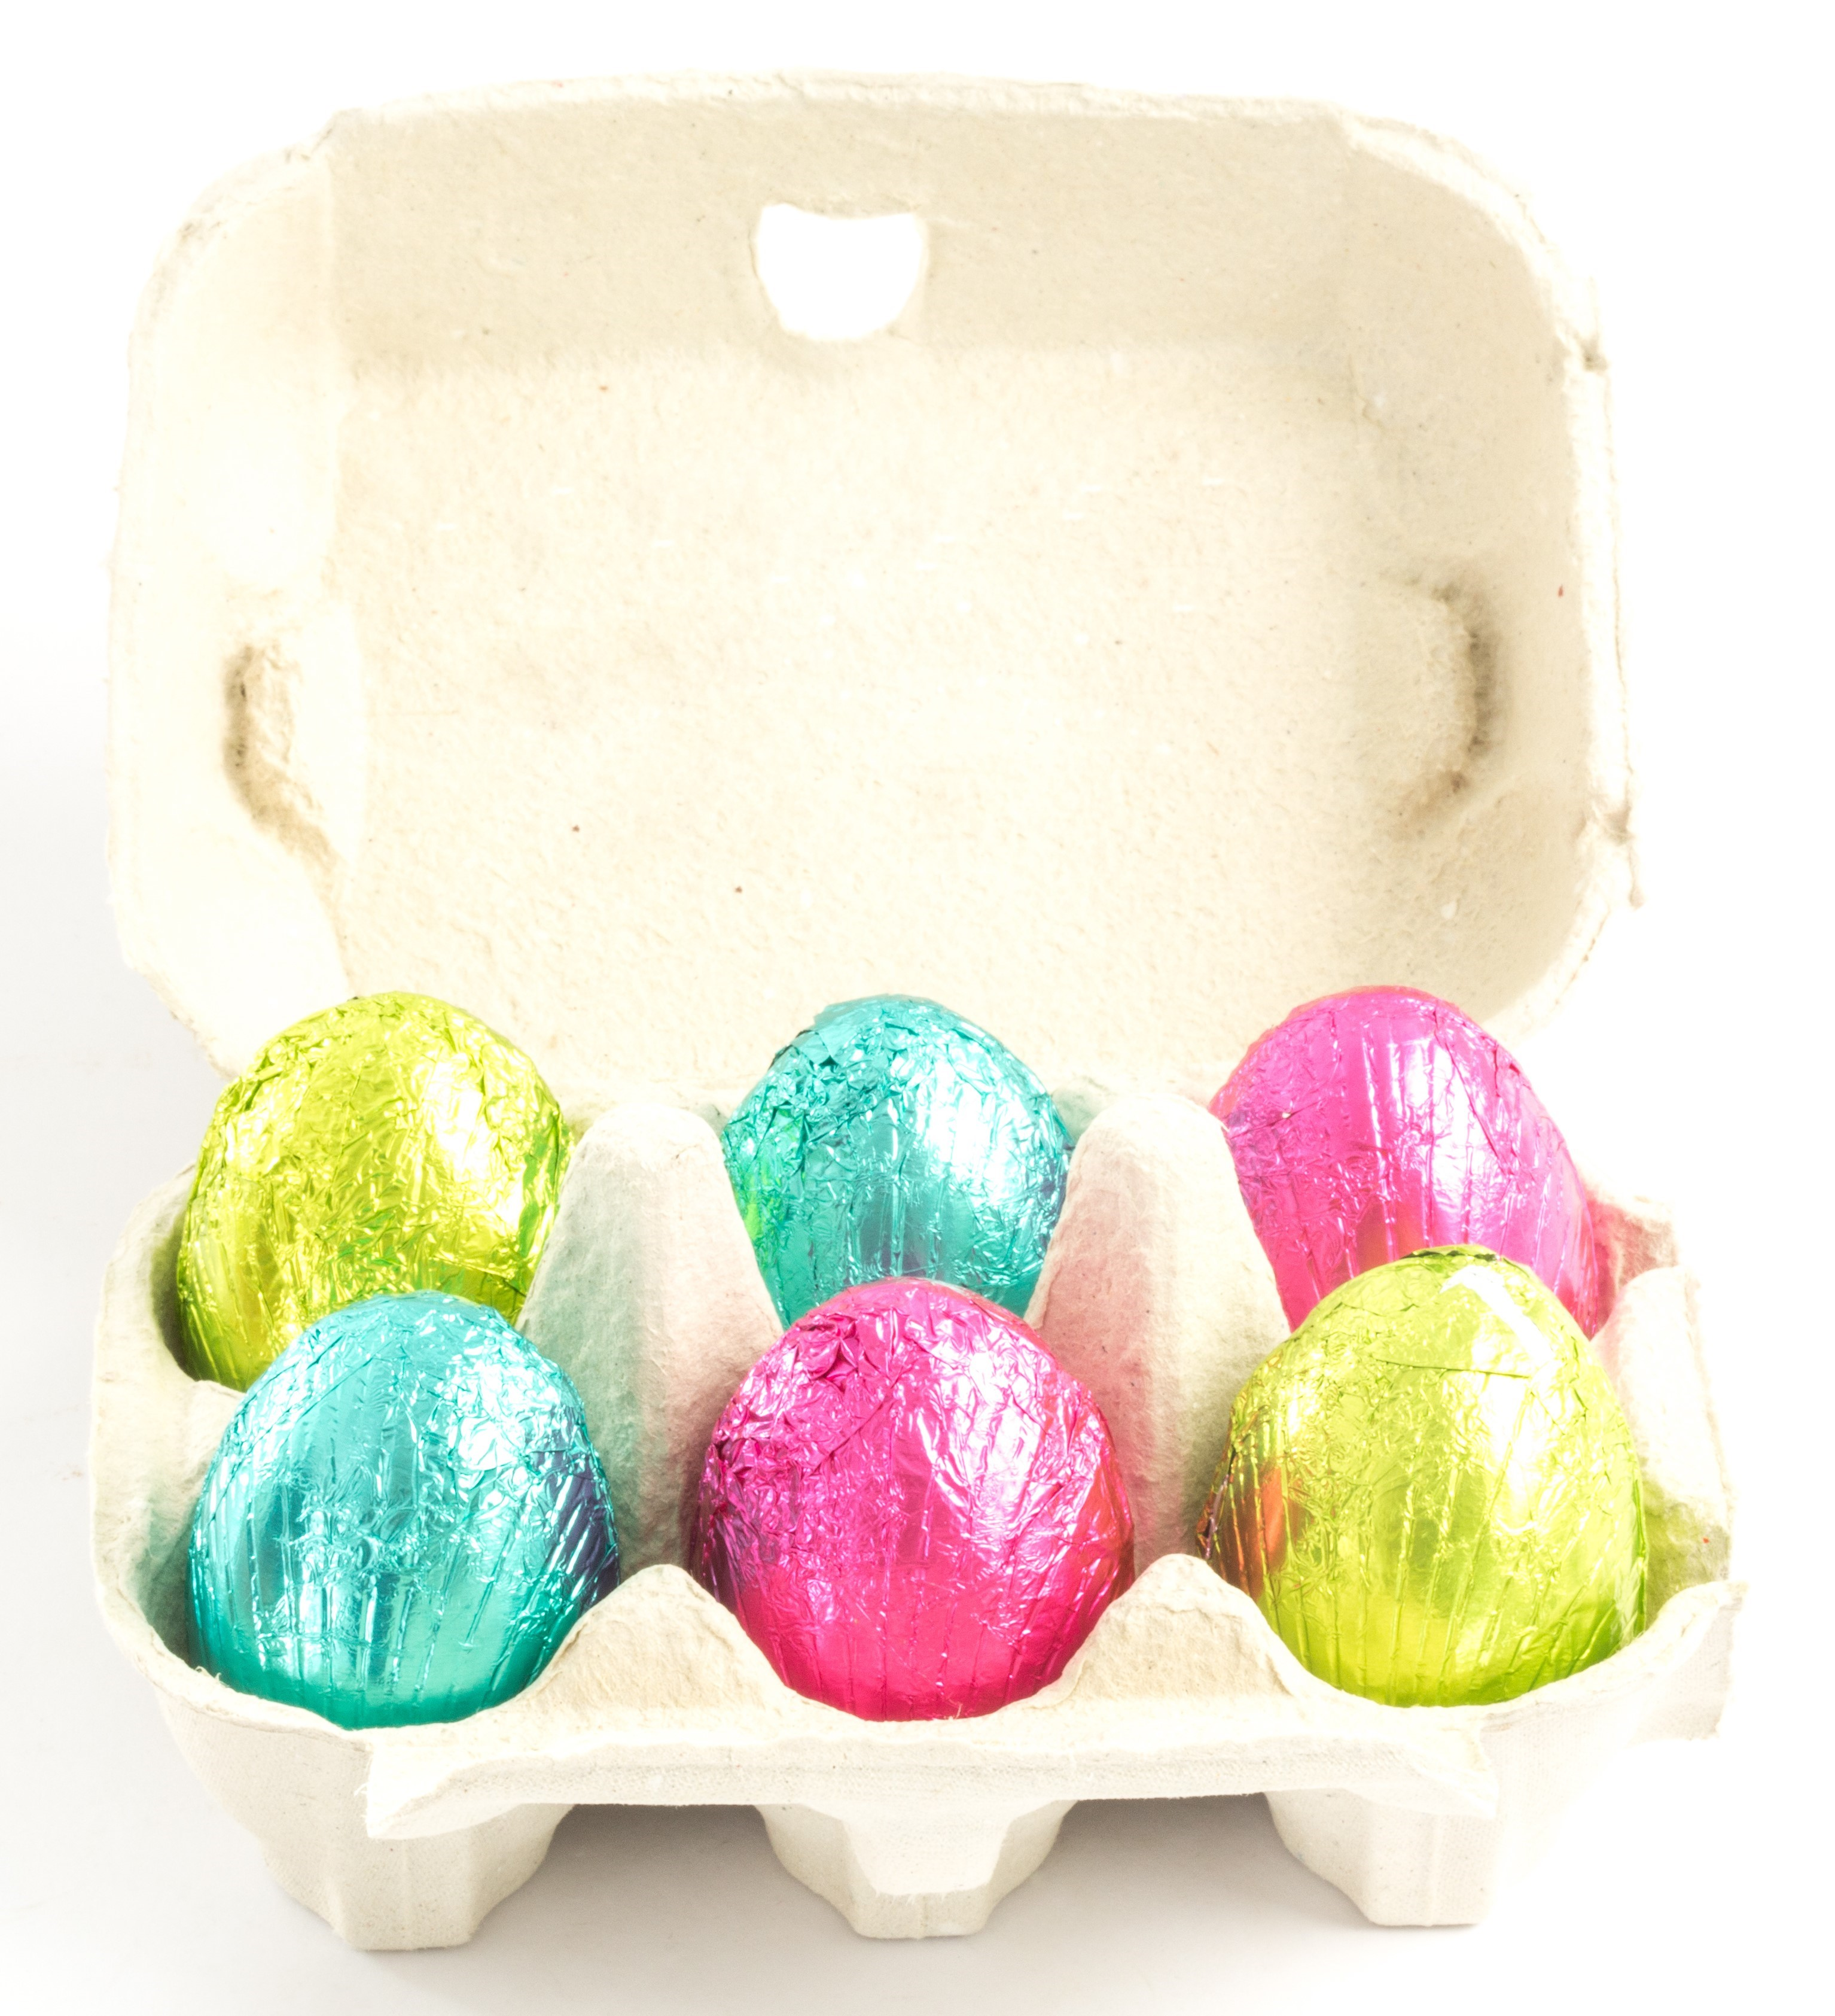 | Jola is going to give everyone some chocolate eggs to take home at the end of the party. They fit into egg boxes which hold 6 eggs each. Will 50 eggs be enough for each of the 8 party guests to have a box of eggs?

